PDSA Cycles

Overview
The model for improvement provides a framework for developing, testing and implementing changes leading to improvement.

Using PDSA cycles enables you to test out changes on a small scale, building on the learning from these test cycles in a structured way before any change ideas are fully implemented. This will allow opportunities to see if the proposed change will succeed and to learn from ideas that might or might not work.

PDSA Cycles:
Act:  - Adopt, adapt or abandon  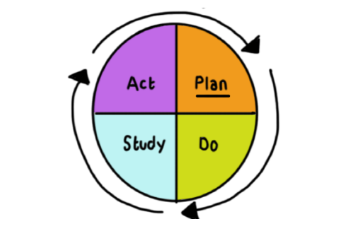  - Plan the next cycle  - Decide whether the change  can be implemented | Plan:  - Plan the change to be tested  - Define the objective, questions and predictions  - Plan to answer questions  - Plan data collection
Study:  - Study measurable outcomes  - Complete the analysis of the data  - Compare data to predictions  - Summarise what was learned | Do:  - Carry out the test or change  - Carry out the plan  - Collect the data  - Begin analysis of the data

What next
Continue with new PDSA cycles and continuous service improvement and document each cycle until you have identified the changes with the greatest benefits. The next stage will be to fully implement the change.

Top Tips for PDSA cycles:
- Plan multiple cycles to test ideas.
- Test on a really small scale. For example, start with one patient or one clinician at one afternoon clinic and increase the numbers as you refine the ideas.
- Test the proposed change with people who believe in the improvement.
- Record PDSA’s as you complete them over time in order to capture the learning and demonstrate the improvement journey.
- Only implement the idea when you’re confident you have considered and tested all the possible ways of achieving the change.

Documenting your PDSA
The following template will help support you in documenting each PDSA cycle in order to analyse information collected and review if further PDSA cycles are required.

Aim (overall goal for this project) – what is your SMART aim
PDSA Cycle No:
Change idea:
PDSA objective: Describe the objective for this PDSA cycle
What questions do you want answered for this test of change?
Predict what will happen when the test is carried out.
Measures to determine if prediction succeeds

Plan:
List the tasks needed to set up this test of change | Person responsible | When to be done | Where to be done

Do: Describe what happened when you ran the test

Study: Describe the measured results and how they compared to the predictions

Act: Describe what modifications in the plan will be made for the next cycle from what you learned

