Date of event: Name of event:
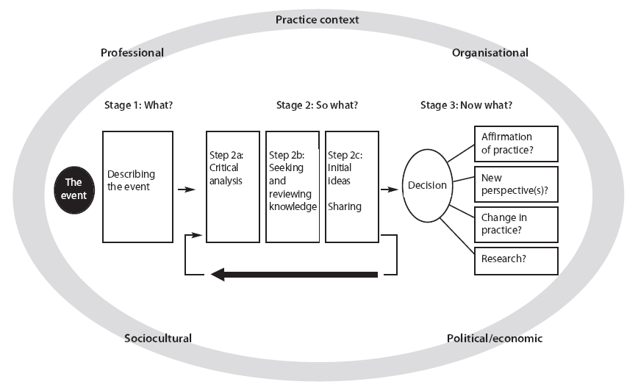 | Professional context (e.g. staff involved, level of staff experience with client/with event etc) | Organisational context (e.g. staffing levels, department culture, workload pressures etc)
 | Sociocultural context (client’s and staff’s beliefs and experiences influencing this event) | Political context (e.g. external influences on decision making, vested interests of client or staff influencing decisions etc)

Stage 1: What?
Describe the event?

Stage 2: So What?
2a: Clinical analysis

2b: Seeking and reviewing knowledge

3b: Initial Ideas- sharing

Stage3: Now What?
Affirmation of practice

New prospective(s)

Change in practice

Research

