Consider the four domains required for decision making:
What evidence do you have from research? | What is your clinical judgement?
What are the client’s values? | What resources are available?
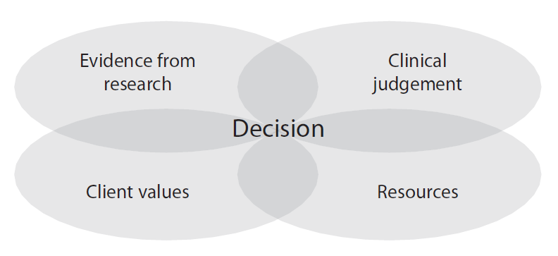
Once you have completed all four boxes what is your decision?

